ASSIGNMENT: Functions & Loop-Based Number Analysis

Description
This assignment demonstrates the use of Python functions and loops to analyze numeric data. The program defines a function that calculates the sum of numbers from 1 to N. A for loop is used to iterate through the numbers, and a break statement stops the loop when the number exceeds 50.

Objective
• Define Python functions
• Use parameters and return values
• Implement loops
• Use loop control statements such as break

Python Code
def sum_numbers(n):
total = 0
for i in range(1, n + 1):
if i > 50:
print("Loop stopped because number exceeded 50")
break
total += i
return total
n = int(input("Enter a number: "))
result = sum_numbers(n)
print("Sum of numbers:", result)
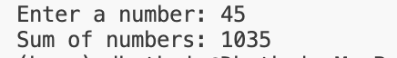
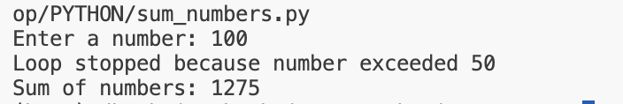

Python Activity & Assignment

ACTIVITY: Conditional Statement Practice

Description
This demonstrates the use of conditional statements in Python to determine whether a person is eligible to vote based on their age.

Python Code
age = int(input("Enter your age: "))
if age >= 18:
print("You are eligible to vote.")
else:
print("You are not eligible to vote.")
